**Benefits Report**

*Produced for Linktree*

*For an Air Force Active enlistment.*

**Recruiter**: williamstravis

**Email**: travis.williams.27@us.af.mil

**Work Phone**:

**Mobile Phone**:

Table of **Contents**

**­­01 - Money** 3

Income 3

Pay Increases 5

Membership Perks 7

**02 - Advancement** 9

Promotions 9

Professional Development 9

Commissioning Programs 10

Pay Grade to Civilian Job Level Comparison 10

**03 - Travel** 12

Air Force Locations 12

Current Air Force Programs 12

Information, Tickets & Travel 13

**04 - Training** 14

Training Types 14

Example Resume 15

**05 - Education** 17

A Path to Higher Learning 17

Education Programs 17

School Funding Benefits 20

**06 - Recreation** 21

Physical, Base, Outdoor & State Recreation 21

**07 - Satisfaction** 24

**08 - Security** 25

Job Security 25

Medical Care 26

Blended Retirement System 28

**09 - Applicant Timeline** 31

# **­­01 - Money**

## Income

Your Air Force salary "basic pay" increases with pay grades and time served. Your basic pay may seem low compared to a civilian job, but it is more like disposable income because the Air Force provides many "in-kind" benefits that civilians have to pay for. These in-kind benefits include housing, meals, and medical insurance. While your basic pay is taxable, your in-kind benefits aren’t. We've taken those into account and calculated your Total Compensation or "Adjusted Basic Pay," so you can have a comparison between what you *really* get in the Air Force to a civilian pay scale.

Below are annual basic pay rates for Airmen.

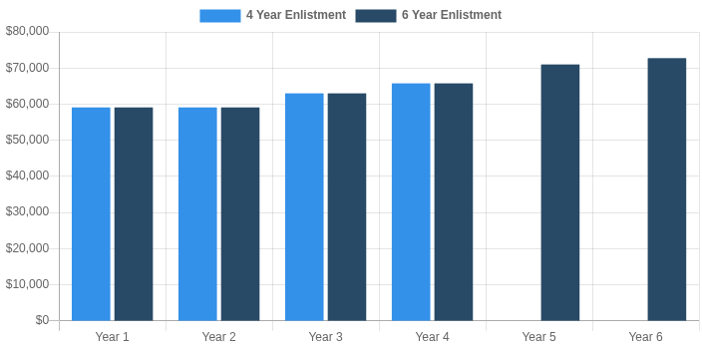

|  |  |  |  |  |  |  |  |  |
| --- | --- | --- | --- | --- | --- | --- | --- | --- |
|  | **Avg Basic Pay** | | **Avg BAH** | **Avg Meals** | **Avg Medical** | **Avg Tax Savings** | **Avg Adj Basic Pay** | **Total Enlistment Earnings** |
| **4 Year Enlistment** | | $31,084 | $19,692 | $5,523 | $1,327 | $4,360 | $61,724 | $246,894 |
| **6 Year Enlistment** | | $33,986 | $19,809 | $5,523 | $1,327 | $4,813 | $65,097 | $390,581 |

4-Year Enlistment: Assuming I enlist for **4 years** as an **E-3** and achieve **Standard** promotions to **E-4** during my first enlistment, I could earn an adjusted pay of around **$59,085** during my first year, working up to **$65,745** in my fourth year.

6-Year Enlistment: Assuming I enlist for **6 years** as an **E-3** and achieve **Standard** promotions to **E-5** during my first enlistment, I could earn an adjusted pay of around **$59,085** during my first year, working up to **$72,708** in my sixth year.

## Pay Increases

Annual Cost of Living Increase

Annual military basic pay raises are linked to the increase in consumer prices, as measured by the Consumer Price Index (CPI). You don’t need to wait and negotiate for a raise like civilians, as these increases are automatically added to your basic pay.

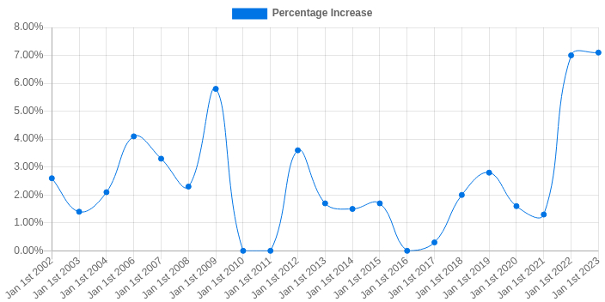

Promotion & Seniority Increase

In the Air Force, every Airman is paid equally based on their rank (hence, "pay grade") and years of service. But your base salary is only part of the overall package you receive. Below are monthly basic pay rates for Airmen:

## Membership Perks

When you're in the Air Force, you're a part of a community. In fact, Air Force bases are basically self-contained cities with everything you need to live and raise your family. Here are some additional membership perks that show how much the Air Force helps take care of you and your family in everyday life.



VA Home Loans

VA-direct and VA-backed home loans can help Veterans, service members, and their eligible military spouses to buy, build, improve, or refinance a home. You'll still need to have the required credit and income for the loan amount you want to borrow, but a VA home loan often offers better terms than with a traditional loan. For example, nearly 90% of VA-backed loans are made with no down payment. VA home loans are earned after 6 years of service for Reservists.

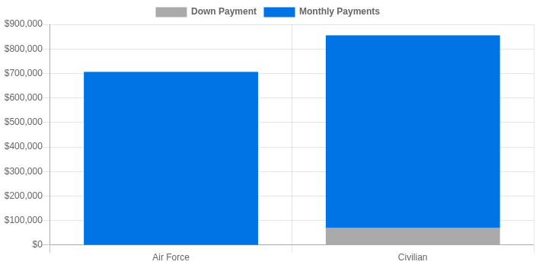

|  |  |
| --- | --- |
| Store  Base Exchange  The Base Exchange (or Military Exchange) is an on-base convenience that offers tax-free products. Typically, you'll find grocery stores (the commissary), food courts, uniform stores, and other specialty shops offering products at a lower rate for service members. | Apple  Commissary  Commissaries are on-base stores that sell discounted groceries to authorized customers like Airmen and their families. By law, commissaries must have an average baseline savings of 23.7% compared to grocery stores available to civilians off base. |
| Piggy Bank  Civilian Business Discounts  Hundreds of companies offer year-round discounted products and services for Active Duty and prior-service Airmen. Whether you're looking to purchase a car, shopping for home improvements, or booking a trip, you can likely find a way to save over your civilian counterparts. | Shirt  Clothing Allowance  While the Air Force does provide your first set of uniforms when you begin training, they become your responsibility as you move up in the ranks. In order to help offset this personal cost, the Air Force provides additional funds to help pay for your uniform and other clothing costs throughout your career. These allowances include funds for initial clothing, replacements and extras, and uniform maintenance. |

The Air Force provides many more benefits and community features when you're [living on base](https://www.airforce.com/lifestyle/life-on-base).

# **02 - Advancement**

## Promotions

You will have regular opportunities for advancement. For enlisted Airmen, a typical promotion timeline looks like this:

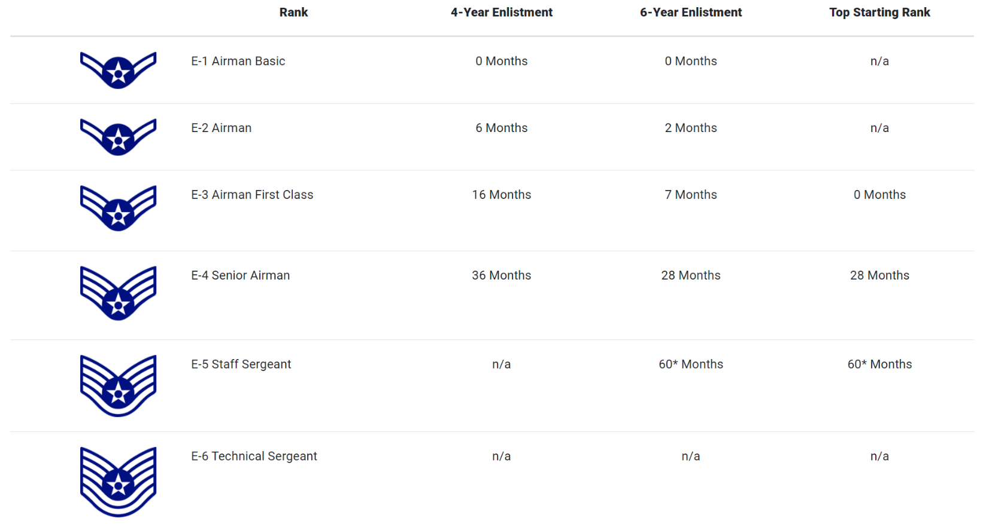*\* Average time to reach E-5. E-5 promotions are based on WAPS testing (see below for details).*   
*\*\*The top rank that can be earned for initial enlistment is E-3/Airman First Class. You may earn an initial enlistment rank of E-1, E-2 or E-3 with 20 or more semester hours of credit from a degree-granting college/university or through: 1) Boy or Girl Scouts, Eagle Scout or Gold Award, 2) JROTC or AFROTC, 3) Billy Mitchell, Amelia Earhart or Carl Spaatz Award or 4) Civil Air Patrol. Talk to your recruiter for more information.*

For enlisted Airmen, the promotion timeline looks like this:

|  |  |
| --- | --- |
| E-1 to E-4 Promotions   * Airman Basic (E-1) is eligible for promotion to Airman (E-2) with six months’ time-in-grade. * E-2 is eligible for promotion to Airman First Class (E-3) with 10 months’ time-in-grade. * E-3 is eligible for promotion to Senior Airman (E-4) within 18 to 24 months’ time-in-grade (depending on earlier promotions). | E-5 + Promotions  Promotion to Staff Sergeant (E-5) and beyond is based on how hard you study and apply yourself.  Note that most Airmen take two, 100-question tests. One, commonly called the SKT (Specialty Knowledge Test), is used to compute your job knowledge score. The other, commonly referred to as the PDG (Professional Development Guide), is used to compute your overall Air Force military knowledge. You will have all the study materials that you will need to prepare for these tests. |

## Professional Development

Continued education and training are critical in preparing Airmen to meet emerging challenges throughout their careers. We operate in an unpredictable landscape which requires flexibility and responsiveness in the Air Force’s developmental education processes, resulting in a variety of professional training opportunities for Airmen of all levels. We are focused on making simple, transparent and agile systems that are responsive to the Air Force's and Airmen's training needs so all Airmen can reach their full potential.

|  |  |
| --- | --- |
| **Professional Military Education**  We pride ourselves in providing every Airman with unsurpassed educational opportunities to develop into even stronger Airmen. We invest time and resources to fuel innovation to help you achieve your goals and bring out your highest potential. | **Other Professional Development Programs**  When you enlist straight out of high school, the Air Force offers exclusive programs and hands-on experience to help you develop your skills and advance in your career. With financial assistance available every step of the way, we provide you with the opportunity to take your training and education as far as you strive to go. |

## Commissioning Programs

If you enlist in the Air Force, you may work toward becoming an Air Force Officer at a later point in your career. But if you aspire to be an officer, we suggest you examine the officer path carefully to decide whether you can meet requirements before joining. For example, if you are already in or aspire to attend college, the Air Force can help you continuing education opportunities and financial assistance. If you enlist, the Air Force offers many opportunities for growth throughout your career.

|  |  |
| --- | --- |
| **Leaders Encouraging Airmen Development (LEAD)**  This program delegates authority to unit and wing commanders to nominate highly qualified Airmen to attend the Air Force Academy. | **The Nurse Enlisted Commissioning Program (NECP)**  People selected for NECP receive a tuition and fees scholarship for up to $15,000 per year as well as a textbook allowance of $600 per year. Those selected may participate for up to three years, depending on their degree programs and previous academics. |
| **The Airman Scholarship and Commissioning Program (ASCP)**  This program offers Airmen the opportunity to earn a commission while completing their bachelor's degree in a variety of fields, including technical, nontechnical, nursing, pre-health and foreign language areas. | **Professional Officer Course-Early Release Program (POC-ERP)**  This program is open to students in all majors who are within two years of completing all bachelor's degree and commissioning requirements. |

## Pay Grade to Civilian Job Level Comparison

This section explains how your military pay grade translates to civilian job levels. Many successful civilian employers focus more on hiring by pay grade than by military occupation. The shaded boxes denote the best comparison between your military pay grade and potential civilian job levels.

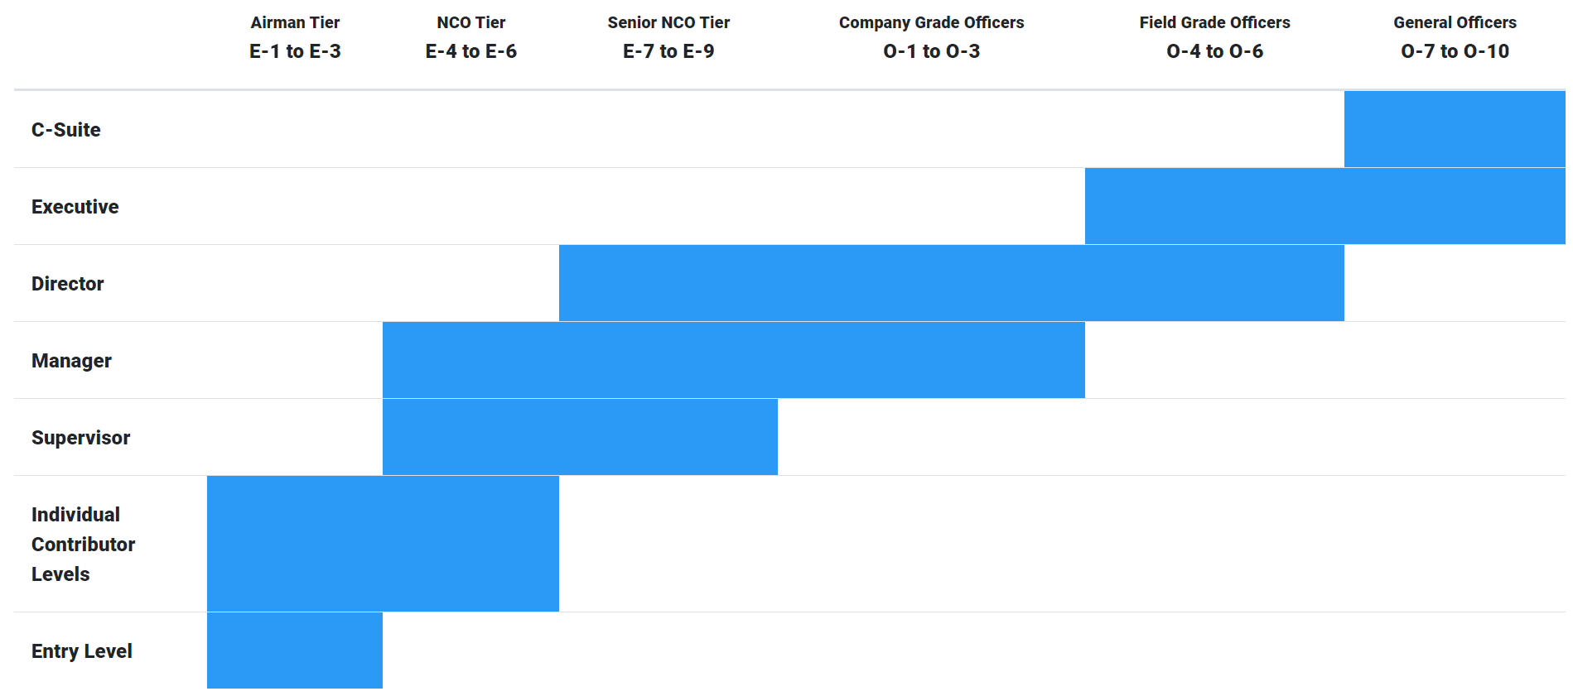

# **03 - Travel**

## Air Force Locations

With bases spanning three continents, there's a need for Airmen all over the world. Find out where your career could take you.

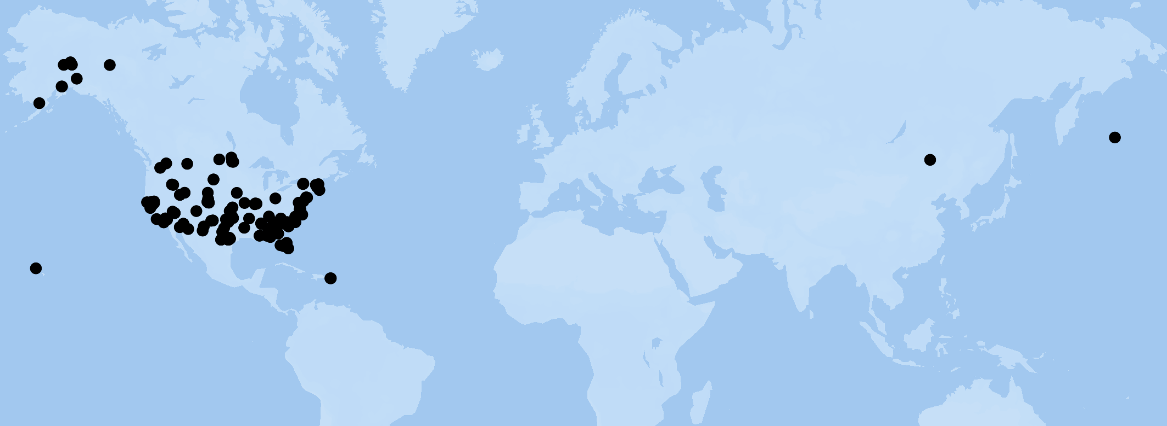

## Current Air Force Programs

|  |  |  |
| --- | --- | --- |
| [**Permanent Duty Station**](https://www.myairforcebenefits.us.af.mil/Benefit-Library/Federal-Benefits/Permanent-Change-of-Station-(PCS)-CONUS?serv=26)  After military and technical training for enlisted Airmen, you'll be assigned to the base location that can best utilize your skills. Active duty Airmen who make a Permanent Change of Station “PCS” are entitled to receive permanent change of station services and allowances to help manage the move. PCS opportunities will depend on AFSC and position availability.  With position availability in mind, your preferred locations are considered. Whenever possible, we try to match an Air Force need with your assignment preferences. In addition, your pay is adjusted to include the cost of living allowance based on your new location. | **Temporary Duty**  A "TDY" is a temporary assignment, usually intended to attend a school, conference, temporarily help an undermanned unit, or participate in an exercise. TDY at any one location is limited to no more than 180 days.  When on TDY, the Air Force pays for costs incurred at a per diem rate.  When the mission of the TDY is complete, the Airman returns to his/her permanent duty assignment. | [**Help Our People Save (HOPS)**](http://www.militaryhops.com/)  Air Force members can enjoy “space-a”, or space available travel. These flights are also called “hops” and allow the service member and dependents to travel anywhere a military flight is going on a space available basis for free or for a very small fee (such as $15). |

## Information, Tickets & Travel

All Airmen receive 30 days of paid vacation per year, during which they are free to travel and take time to explore local and foreign destinations. Airmen can take advantage of available space on Air Force aircraft to travel to many international destinations as well as almost any state in the U.S. For destinations near another military facility, they can enjoy hotel-quality lodging on base for a reduced cost. It all amounts to a lifetime of adventure and travel for you and your family to enjoy throughout your United States Air Force career.

|  |  |  |
| --- | --- | --- |
| **Discount Event Tickets**  Typically, you can expect an eight-hour workday, leaving plenty of time to relax, recharge and do other things you enjoy once you change out of uniform. Hundreds of companies offer military discounts to service members, retired military, veterans, spouses and their families. | **Low Cost Travel**  Bases offer travel planning to help Airmen make the most of their 30 days of paid vacation per year. Enjoy complimentary flights that make it easy and affordable to meet family or friends at any home or vacation destination. | **Low Cost Vacation Packages**  You will be eligible to stay in base lodging around the world. This includes lodging at any military facility that has rooms available for military personnel and their families, at a cost much lower than a hotel off base. |

[Air Force ITT (Information, Tickets & Travel)](http://www.myairforcelife.com/ITT/) is a team of more than 75 offices, staffed by nearly 300 travel agents who are eager to help with your travel or recreation plans. ITT operations vary from base to base, but most bases have a discount ticket sales office. In fact, many offices offer full travel services.

# **04 - Training**

## Training Types

Enlisting in the Air Force immediately enrolls you in the Community College of the Air Force (CCAF) and puts you on a path of higher education through the pursuit of an Associate Degree of Applied Sciences. You will also benefit from the structured earn-while-you-learn U.S. Military Apprenticeship Program as you progress through your technical training and experience on the job. You are also encouraged to secure several civilian licenses and credentials that are critical to your Air Force career. Finally, as you grow in your job and secure promotions, you will be offered leadership training and supervisory opportunities. Here is a high-level look at your Air Force training:

|  |  |
| --- | --- |
| [**Basic Military Training**](https://www.airforce.com/education/military-training/bmt)  We pride ourselves in providing every Airman with unsurpassed educational opportunities to develop into even stronger Airmen. We invest time and resources to fuel innovation in order to help you achieve your goals and bring out your highest potential. | [**Technical Training**](https://www.airforce.com/education/technical-training)  When you enlist straight out of high school, the Air Force offers exclusive programs and hands-on experience to help you develop your skills and advance in your career. With financial assistance available every step of the way, we provide you with the opportunity to take your training and education as far as you strive to go. |
| [**Upgrade Training**](https://drive.google.com/file/d/1cMBVgzSJ2N3Dfy6tHNWp0XCjrPfipx5j/view)  In the Air Force, progressing is an important part of your job. To help you become the best you can be, you will have opportunities for continuous learning and training as you continue your upward momentum through your career. Programs are designed to help you progress in your career, take on more responsibilities, and stay current with advancements in technology and tactics.  The specific requirements and opportunities for upgrade training in the Air Force can vary widely depending on the career field, rank, and individual goals. | **Leadership Training**  As you progress through your career, you'll also share ideas, experiences, and work together with your fellow Airmen to achieve various educational objectives through the Thomas N. Barnes Center for Enlisted Education. We've included some of the most sought-after leadership training programs below. Click on any to learn more:  [Airman Leadership School](https://www.airuniversity.af.edu/Barnes/Airman-Leadership-School/)  [Noncommissioned Officer (NCO) Academy](https://www.airuniversity.af.edu/Barnes/NCO-Academy/)  [Air Force Senior Noncommissioned Officer Academy (AFNCOA)](https://www.airuniversity.af.edu/Barnes/AFSNCOA/) |
| **Enlisted Professional Military Education** |  |
| Air Force Enlisted Professional Military Education (EPME) is created and provided through the Thomas N. Barnes Center for Enlisted Education. EPME courses include fitness and drill and ceremony components as well as formal lectures and academic research projects. | Air Force EPME courses have been approved for college credit in the Leadership, Management & Military Science discipline of the service's Community College of the Air Force Associate in Applied Science degree programs. |

## Example Resume

Based on the experience gained from Basic Military Training, Technical Training, Upgrade Training, and Leadership Training, you will become a true Airman with a well-rounded career trajectory. Importantly, you will also look good "on paper". As an example, we've included a sample of what your resume could look like after an enlistment:

|  |  |  |
| --- | --- | --- |
|  | **Air Force Specialty Code**  An Air Force Specialty Code "AFSC" is the job that an Airman performs while serving. You will gain valuable experience during this time, preparing you for a career in the workforce. Here's some information on the AFSC currently selected:  **AFSC**: In-Flight Refueling - 1A0X1  **AFSC Description**: Performs in-flight refueling aircrew functions and activities according to flight manuals, checklists, and United States Air Force publications. Related DoD Occupational Subgroup: 105000. | |
|  | **Education**  Associates of Applied Science in **Aviation Operations(4VCB)**.  The **Aviation Operations(4VCB)** major program includes technical and on-the-job education, leadership/management and military studies, physical education, general education (communications, mathematics, social science, and humanities), as well as program electives for you to choose from such as natural science courses or a foreign language. | |
|  | **Training and Credentials**  In addition to your **Aviation Operations(4VCB)** degree, you will receive additional on-the-job (or "occupational") training that will result in your ability to gain certifications and credentials to prove to future employers that you have the skills necessary to succeed in a variety careers in the civilian job market. You will gain some during your time in the Air Force, but your options also open with civilian credentials that you can target as you understand what path you want to take your career. We have provided samples below.  Available Credentials*:  Certified Safety Professional (Csp), Registered Hazardous Substances Professional (Rhsp), Associate Electronics Technician (Ceta), General Radiotelephone Operator License (Pg), Radar Electronics Technician (Rad), Certified Safety Specialist (Wso-Css), Certified Instructional Trainer (Cit), Certified Hazardous Materials Manager (Chmm), Ncatt Radio Communication Systems (Rcs), Ncatt Dependent Navigation Systems (Dns), Construction Health And Safety Technician (Chst), Certified Aviation Manager (Cam), Certified Electronics Technician - Associate-Level (Associate Cet), Certified Electronics Technician - Journeyman-Level - Communications, Certified Electronics Technician - Journeyman-Level - Computer, Certified Electronics Technician - Journeyman-Level - Industrial, Certified Control Systems Technician - Level Ii (Ccst-Ii), Certified Control Systems Technician - Level Iii (Ccst-Iii), Certified Electronics Technician - Journeyman-Level - Radar, Certified Logistics Technician (Clt (Ae)), Global Logistics Associate (Gla), System Operator Certification, Iso 9001 Foundation - Quality Certification, Certified Governmental Safety Officer (Wso-Cgso), Certified Governmental Safety Specialist (Wso-Cgss), Certified Petroleum Apprentice (Cpa) Level 1, Certified Hazard Control Manager-Security (Chcm-Sec), Certified Emergency Disaster Professional (Cedp), Safety Management Specialist (Sms), Reliability Operator Certification (Rc), Balancing, Interchange, And Transmission Operator Certification (Bt), Transmission Operator Certification (To), Balancing And Interchange Certification (Bi), Certified Quality Improvement Associate (Cqia), Certified Manager Of Quality/Organizational Excellence (Cmq/Oe), Certified Quality Technician (Cqt), Six Sigma Black Belt (Cssbb), Certified In Transportation And Logistics (Ctl), Aircraft Dispatcher, Certified Manager (Cm), Certified Packaging Professional (Cpp), Certified Mail Manager (Cmm), Certified Associate In Materials Handling (Camh), Professional Certified In Materials Handling (Pcmh), Certified Professional Public Buyer (Cppb), Certified Public Procurement Officer (CPPO), Wireless Communications Electronics Technician (Wcm), Certified Fire And Explosion Investigator (Cfei), Occupational Hygiene And Safety Technologist (Ohst), Certified In Production And Inventory Management (Cpim), Incident Safety Officer - Fire Suppression (Iso), Certified Calibration Technician (Cct), Electrical Testing Technician (Ett) - Level Ii, Electrical Testing Technician (Ett) - Level I, Electrical Testing Technician (Ett) - Level Iii, Certified Associate In Project Management (Capm), Certified Maintenance And Reliability Professionals (Cmrp), Avionics Electronics Technician (Avn), Ic3 Digital Literacy Certification (Ic3), Certified Mail And Distribution Systems Manager (Cmdsm), Certified Aerospace Technician Core, Ncatt Aircraft Electronics Technician (Aet), Certified Supply Chain Professional (Cscp), Certified Hazardous Materials Practitioner (Chmp), Certified Professional In Supply Management (Cpsm), Sae Fabricator (Sff), Ncatt Foreign Object Elimination (Foe)  *\*Note: Credentials earned in the Air Force are directly applicable to civilian careers.* | |
|  | **Experience**  One of the clearest ways the Air Force helps you distinguish yourself from your civilian counterparts is helping you gain higher experience levels from the moment you enter the workforce. "Experience" can be divided into two categories: Technical and Leadership. | |
| Technical Experience  Technical Experience is what you get when you begin performing a job. In fact, you could replace "technical" with "on-the-job" experience to better understand the term. Because you begin a job (or an "occupation") in the military after you join the Air Force, you immediately begin gaining job skills that you can use in your next career.  **Technical**: Number of Years: 4 Year Contract Achievement Level: 3 | Leadership Experience  Leadership Experience relates to how long you have led teams of people. Leadership achievement levels include Supervisor, Manager, and Director. After you complete Airman Leadership School, you will reach the Supervisor level in which you are responsible for leading small teams of 10-15 persons. This paygrade undergoes a moderate amount of leadership training and is similar in duties to a supervisor in the workforce.  **Leadership**: Number of Years: 0 Achievement Level: Supervisor |

# **05 - Education**

## A Path to Higher Learning

The U.S. Air Force puts every Airman on a path to achieve an Associate's Degree of Applied Sciences by automatically enrolling them into the Community College of the Air Force. Throughout your Basic Military Training, Technical Training (job-specific), and Professional Military Education, you'll begin earning college credits towards your AAS degree. From there, it'll be up to you to finish your degree.

Your education is more in reach with a career in the Air Force.

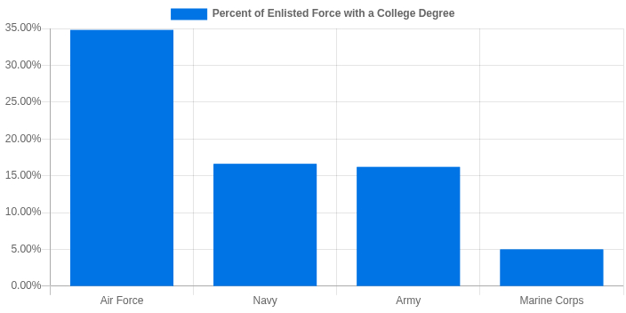

*\*Data from the Percent with a College Degree chart is sourced from Table 2.54 in the 2018 Military Demographics report.*

## Education Programs

The Air Force is here to help you develop your skills and take your career further with continuing education opportunities and financial assistance. Whether you're interested in attending college or have already earned your degree, there are opportunities to enter the Air Force and receive financial support. We will help you discover your skills, earn a degree, learn to lead and take your career with the Air Force to the highest level. Below are just a few of the programs to help get you there.

|  |  |  |
| --- | --- | --- |
| [**Community College of the Air Force**](https://www.airuniversity.af.edu/Barnes/CCAF/)  The Community College of the Air Force (CCAF) is the only degree-granting institution of higher learning in the world dedicated exclusively to enlisted personnel. It offers enlisted Airmen the opportunity to earn a two-year Associate in Applied Science (AAS) degree that pertains to your Air Force career. When you join the Air Force, you're automatically enrolled and will begin earning credits toward a college degree as soon as you begin basic training. ***22,000 Airmen jump start their education each year by earning degrees from CCAF.*** | [**Tuition Assistance Program**](https://www.afpc.af.mil/benefits-and-entitlements/military-tuition-assistance-program/)  Once you enlist, the Air Force Tuition Assistance program pays ***100% of tuition costs for college classes (up to $250 per semester hour or the equivalent, up to $4,500 per fiscal year).*** This is not a loan and is at no cost to you. The program is designed to help active duty personnel pursue voluntary, off-duty educational opportunities and can be taken from two- or four-year institutions on base, off base, or by correspondence. | **[Post-9/11 GI Bill Chapter 33](https://www.va.gov/gi-bill-comparison-tool)**  The Post-9/11 GI Bill gives active duty Airmen the ability to receive up to 36 months of benefits for education and training opportunities outside of the Air Force. Most use these 36 months of benefits over a 4-year period. These benefits may be used for undergraduate and graduate degree programs, vocational and technical training, tuition assistance, books, supplies, and monthly housing. ***Generally, benefits are payable for 15 years following active duty and may be transferred to a spouse or children. That’s a potential***  **$104,660 *gift!*** |
| [**Defense Activity for Non Traditional Education**](https://www.getcollegecredit.com/test_takers/active-duty-veteran-military-members/)  The Defense Activity for Non Traditional Education "DANTES" offers credit-by-examination in more than 60 different subject areas for military members (active duty, Guard, and Reserve components) and members of the Coast Guard and Coast Guard Reserve.  DANTES Subject Standardized Tests (DSST) are programs that allow you to earn college credit by taking and passing exams in various subject areas. DANTES funds the exam fee for the first attempt for each test title. | [**College Level Examination Prep**](https://clep.collegeboard.org/earn-college-credit/military-benefits)  The College-Level Examination Program (CLEP) is a program that allows you to earn credit for college courses by passing exams in various subject areas.  Both CLEP and DSST are developed by institutions and evaluated by the American Council on Education (ACE). | **[Yellow Ribbon Program](https://www.va.gov/education/about-gi-bill-benefits/post-9-11/yellow-ribbon-program/)**  The Yellow Ribbon Program can help you pay for higher education out-of-state tuition, private school, or graduate school tuition that the Post-9/11 GI Bill doesn’t cover. |

|  |  |  |
| --- | --- | --- |
| [**Airman Leadership School**](https://www.airuniversity.af.edu/Barnes/Airman-Leadership-School/)  Airman Leadership School (ALS) is an education program held at base level to prepare Senior Airmen for positions of greater responsibility.  ALS is the first level of the Enlisted Professional Military Education (EPME) continuum and prepares Senior Airmen to be professional, war-fighting Airmen and Space Professionals who can supervise and lead work teams to support the employment of Air and Space power. | [**Noncommissioned Officer Academy (NCOA)**](https://www.airuniversity.af.edu/Barnes/NCO-Academy/)  NCOA is a professional school designed to educate and advance the high ideals necessary for leadership, teamwork, good order and discipline in the U.S. Air Force and U.S. Space Force.  The Noncommissioned Officer Academy (NCOA) is the second level of EPME and prepares Technical Sergeants to be professional, war-fighting Airmen and Space Professionals who can manage and lead units in the employment of Air and Space power. Currently, there are 10 NCOAs worldwide. | [**Senior Noncommissioned Officer Academy**](https://www.airuniversity.af.edu/Barnes/AFSNCOA/)  The Air Force Senior Noncommissioned Officer Academy (AFSNCOA) is a resident CCAF-affiliated program that consists of 200 classroom hours.  The curriculum prepares SNCOs for increased leadership responsibilities in the joint, combined, and inter-agency operating/strategic environment. AFSNCOA is the third level of EPME.  AFSNCOA prepares senior NCOs to lead the enlisted force in the employment of airpower in support of US national security objectives. |

## School Funding Benefits

Thanks to the help of the Post-9/11 GI Bill, all service members receive financial benefits for higher education. Benefits include tuition assistance and money for books and housing. We calculated your projected total education funding with a breakdown by year.

|  |  |
| --- | --- |
|  |  |

If I attend **Savannah State University** and graduate in **4 years**, I could receive **$104,660** in total funding from the Air Force Tuition Assistance and Post-9/11 GI Bill benefits that I can use after serving 3 years in the Air Force. ***Generally, GI Bill benefits are payable for 15 years following active duty and may be transferred to a spouse or children.***

**Payments**: Payment for your tuition assistance will be paid directly to your college, either by semester or monthly depending on how your school accepts funding payments. Payments for your book stipend will be made directly to you on an annual basis. Payments for your basic allowance for housing (BAH) will be made directly to you around the end of each month. *Please note that BAH will be paid during the 9 months of the academic year.*

**Taxes**: According to the [IRS](https://www.irs.gov/individuals/tax-exclusion-for-veterans-education-benefits#:~:text=Payments%20you%20receive%20for%20education,on%20your%20federal%20tax%20return.), payments you receive for education, training, or subsistence under any law administered by the VA are tax free. Don't include these payments as income on your federal tax return. So, neither tuition assistance, basic allowance for housing nor your books stipend are taxable.

Understanding Student Loans

Most civilians attending college need to take out some kind of a student loan. So, to understand the true cost of higher education, you need to understand the costs associated with student loans and how they compare to the financial benefit of using the Air Force benefits and Post-9/11 GI Bill. Here's a student loan table that uses current student loan interest rates and provides a variety of term lengths to give you a payment breakdown. ***15- to 25-year student loan terms tend to be the most popular.***

|  |  |  |  |  |  |
| --- | --- | --- | --- | --- | --- |
|  | **25 Year** | **20 Year** | **15 Year** | **10 Year** | **5 Year** |
| **Loan Amount** | $104,660 | $104,660 | $104,660 | $104,660 | $104,660 |
| **Interest Rate** | 6% | 5.5% | 5% | 4.5% | 3% |
| **Monthly Payment** | $674 | $720 | $828 | $1,085 | $1,881 |
| **Total Interest** | $97,638 | $68,126 | $44,316 | $25,502 | $8,176 |
| **Total Payment** | $202,298 | $172,786 | $148,976 | $130,162 | $112,836 |
| **Pre-Tax Earnings Needed\*** | $259,356 | $221,521 | $190,995 | $166,874 | $144,662 |

Your monthly payment for paying **100%** of the **$104,660** cost to attend **Savannah State University** for **4 years** could range between **$1,881 per month** and **$674 per month** depending on the term and interest rate on your student loan.

*\*Note: The tax effect is based on the marginal tax rate set at 22%.*

# **06 - Recreation**

## Physical, Base, Outdoor & State Recreation

Life in the Air Force requires hard work, but also allows time for your own pursuits. Typically, you can expect an eight-hour workday, leaving plenty of time to relax, recharge and do other things you enjoy once you change out of uniform.

|  |  |
| --- | --- |
| **Physical Recreation**  Intramural sports are a popular way to have fun and stay active on all of our bases. With multiple sports facilities on every base, you'll find a way to continue to practice and play the sport of your choice. ​​​​​​ | **Base Recreation**  Each base has its own recreation center equipped with snacks, drinks, billiards, computers, Wi-Fi, arcade and console games, and other activities to help you relax and unwind. [Example Local Base site](https://www.jble.af.mil/). |
| **Outdoor Recreation**  From ski boats to snowboards, you can often find the outdoor gear, equipment and even amenities you need right on base at our rec camp and equipment rental facilities. While it varies from base to base, you’ll almost always find the gear or activity you’re looking for. | **State Recreation**  Many states allow those who are currently serving active-duty military or are on leave from active duty to obtain hunting and fishing licenses for free. Other states give active-duty military members who are stationed in that state the ability to purchase licenses as residents of the state in which they are either stationed or traveling in, even where they claim residency elsewhere. |

Fitness Facilities

In the Air Force, one of your duties is to stay physically fit. It's not a chore - it's a way of life. The Air Force provides great fitness facilities from gyms to tracks to lap pools to fitness classes to help you keep yourself in top physical condition.

Time for Recreation

|  |  |
| --- | --- |
| The Air Force lifestyle offers a work-life balance similar to that of the civilian world. While stationed on base, Airmen typically work at their assigned job 40–45 hours a week leaving plenty of time for recreation.  In addition to Federal Holidays, Airmen are entitled to 30 days of vacation with pay per year.  They also receive 4 to 5 days of family time per year. These are typically days around Thanksgiving, Christmas, New Years, etc. to give families more time together.  *\*Civilian time off is based on Bureau of Labor Statistics* |  |

# **07 - Satisfaction**

Recognition

In the Military recognition comes in the following ways:

|  |  |  |
| --- | --- | --- |
| **Awards**  Whether you enlist in the Air Force or join as an officer, you will have regular opportunities for advancement. | **Decorations**  The Air Force uses medals and ribbons to recognize service members who have performed bravely both in combat and non-combat situations. | **Wear of the Uniform**  Military uniforms distinguish Airmen from civilians. They present an image of togetherness, orderliness, and discipline and add to the Airmen's sense of camaraderie and cohesiveness. |

Service to Country

Service to Country stems from pride, which in turn promotes a sense of satisfaction. Joining the Air Force is a life-changing decision and opportunity. Airmen fulfill important roles in service to our country, enjoy a close-knit community and embrace a global lifestyle. It's a journey that's full of growth. Take time to learn about all aspects of Air Force life, make the right preparations, and discover how joining can be a good fit for your future.

|  |  |  |
| --- | --- | --- |
| **Pride**  Airmen aim high, serving our country and defending our freedom, with commitment and courage most others have never seen. | **Tradition**  The U.S. Air Force is the world's preeminent force in air, space and cyberspace. Through shared values, key capabilities and upholding our Airman's Creed, we continue to achieve our mission and aim high in all we do. | **Patriotism**  Patriotism is an element of the core value commitment - Integrity First, Service Before Self, and Excellence in all we do. |

Belonging

Wingman Culture is said to be one of the best things about serving. The Air Force family includes men and women in uniform, civilian employees, contractors, and the families that support them.

|  |  |
| --- | --- |
| **Teamwork**  When you join the Air Force, you are joining a team of professionals who work together to accomplish the mission at hand. | **Making New Friends**  When you're in the Air Force, you're part of a community. Air Force bases are basically self-contained cities with everything you need to live and raise your family. |

# **08 - Security**

## Job Security

Our #1 goal is to take care of our Airmen. An Airman’s job and pay are guaranteed and include regular opportunities for advancement. A career in the Air Force guarantees you have a job. **A guaranteed job means guaranteed income, with no chance of strikes or layoffs.**

This chart shows the trend in unemployment rates for persons 25 years and older by educational attainment to show you a comparison of what your current unemployment risk is in the civilian job market compared to the security of an Air Force career. You indicated your current education level is **High School**.

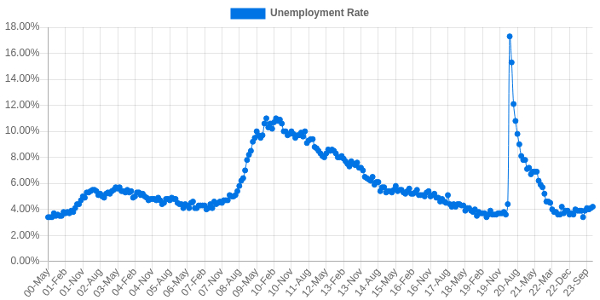

## Medical Care

Our Airmen receive excellent rates, comprehensive medical including **health, dental** and **vision care**, plus **full pay and allowances for sick days** and **low-cost life insurance up to $400,000**. And if you’re ever temporarily disabled due to illness or injury, you’ll still receive a salary. Family members may receive medical care at military or civilian facilities through various options for little or no cost.

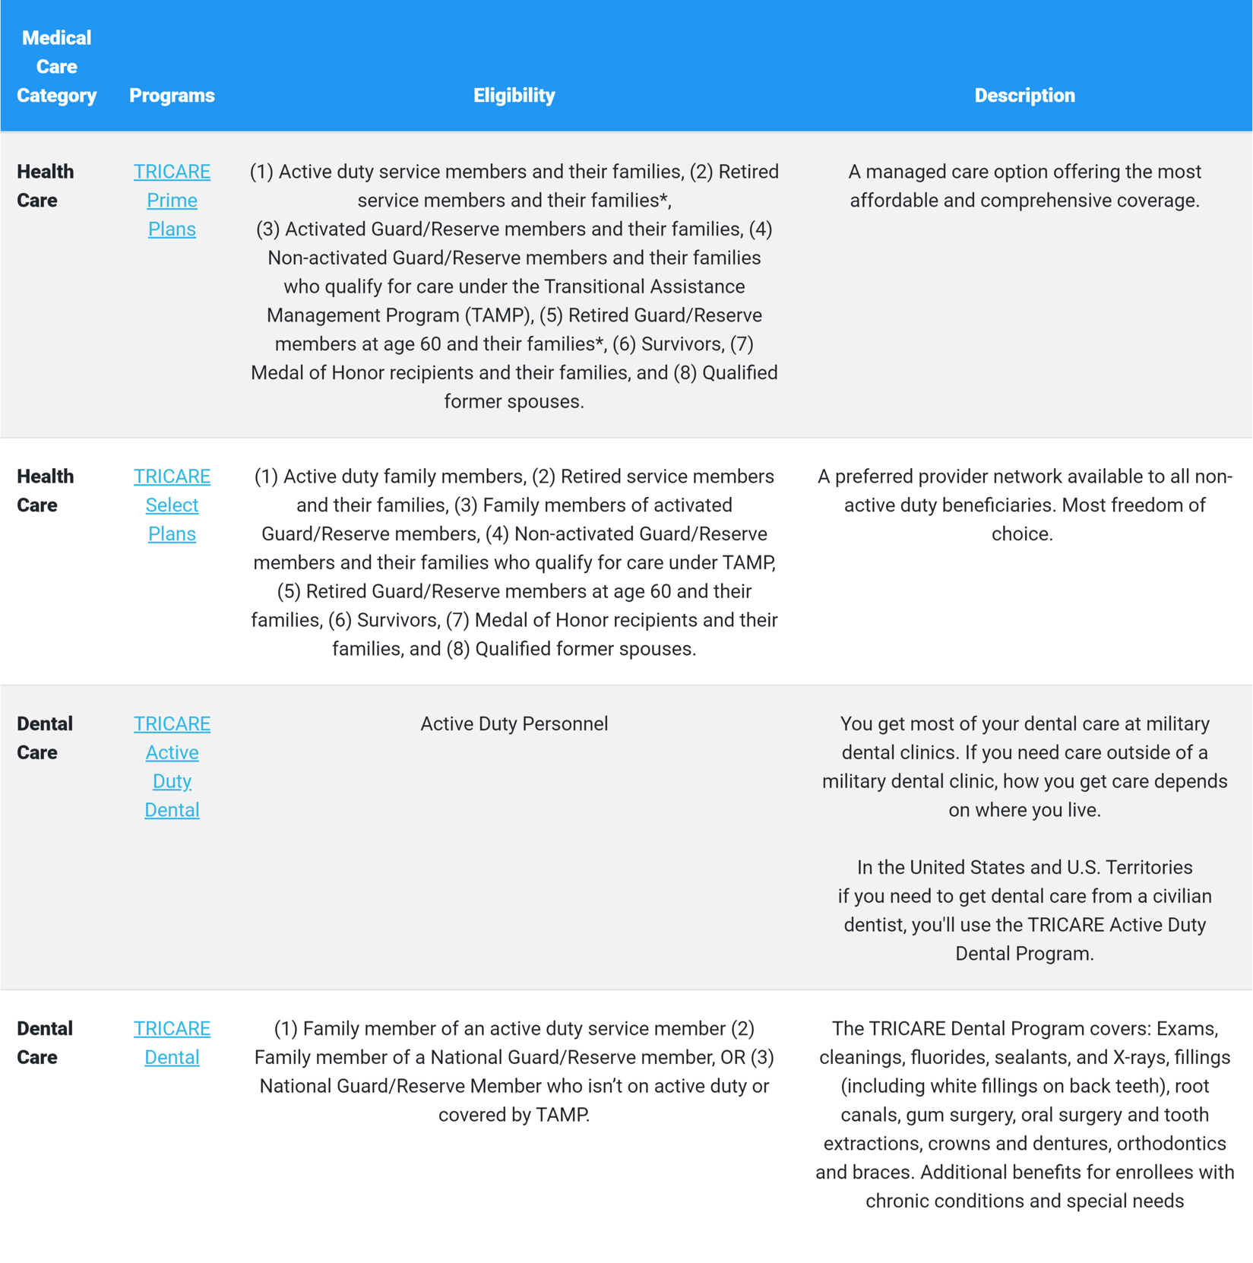

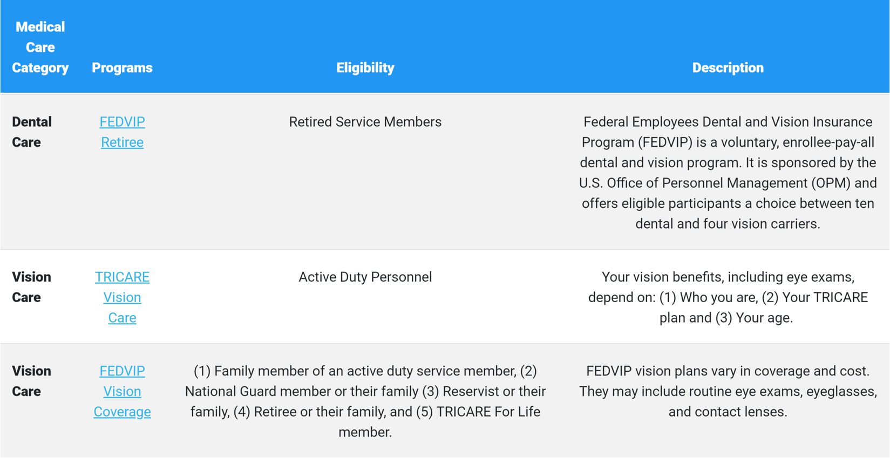

*\*When retired service members and their families become eligible for Medicare based on age, they aren't eligible to enroll in TRICARE Prime.*

## Blended Retirement System

The best kind of career ensures that you can eventually leave it and live comfortably in retirement. Your Air Force career is designed from the beginning to help you save while not sacrificing your daily comfort while you work. Using the Blended Retirement System, service members get:

[1. Retirement Plan](https://drive.google.com/file/d/1xSXXdkNXyhPcpQ77qwPpQR82JGHoveAM/view)

|  |  |
| --- | --- |
| *Your retirement plan starts immediately, and you’re fully vested after 2 years.*  The DoD automatically contributes **1%** of your basic pay to your **Thrift Savings Plan** after **60 days of service**. You'll see **matching contributions** at the **start of 3 years** through the completion of 26 years of service, and...  *Your fully vested- meaning it’s yours to keep – as of the beginning of 3 years of service and your plan goes with you when you leave.* |  |

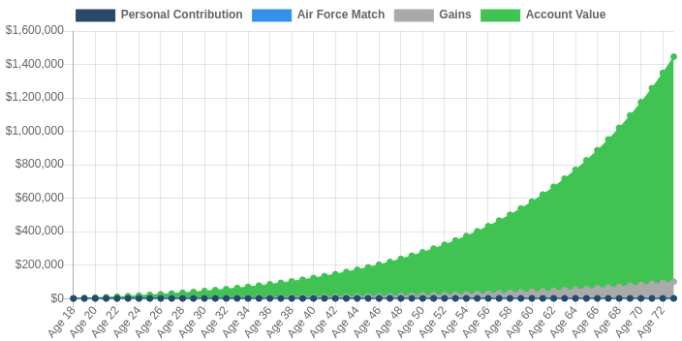

**What this means for me:** If I enlist now as an **E-3** and make **5% Contributions** for **20 years**, I could have roughly **$1,445,940\*** in my Thrift Savings Plan at **age 75\*\***.  
*\*Assuming a 7% real rate of return, which is the* [*30 year average of the S&P 500*](https://www.macrotrends.net/2526/sp-500-historical-annual-returns)*.   
**Assuming an enlistment age of 18.*

**TIP:** Time is the most important factor to harness the power of compound interest. The chart above highlights the exponential growth your retirement could have *if you start early*. One tip is to treat your retirement as a bill, make sure to “pay yourself” first each month by setting up automatic contributions to your retirement fund.

[2. Mid-Career Continuation Pay](https://drive.google.com/file/d/16rqjY6YmaPZftNCgcJKnf69JlRo1m47-/view)

|  |  |  |  |
| --- | --- | --- | --- |
| *Received before 12th year of service.*  A mid-career financial incentive paid to Airmen who are enrolled in the Blended Retirement System (BRS). It is in addition to any career-field-specific incentives or retention bonuses.  Calculated by **(monthly basic pay * 2.5) - tax withholding = net continuation pay**. You must elect to receive it before starting your **12th year of service.** | |  | |
| **$9,987** | **What this means for me:** If I serve at least 12 years, achieve **Standard** **promotions** and reach an E7 pay grade, I could receive a one-time estimated continuation pay of **$9,987.**  **TIP:** People tend to spend what they make. The secret to building wealth is to be disciplined in saving. Remember, *time is your friend* if you let it be. One tip is to understand the opportunity of investing your bonus. Think about it in these terms: If I invested **$9,987**, assuming I earn the average long-term return of the stock market, I could have **$65,745** by the time I retire at **age 65\***. Using this thought process on all your spending can lead to building long-term wealth. *A good rule of thumb is to invest at least half of your bonus.*  *\*Assuming an enlistment age of 18.* | |

*NOTE: You must commit to serve an additional 48 months (concurrent with other service commitments). If you do not complete the obligation, you must repay all or part of your CP. *Title 37 USC, Sec. 373 and DoD Financial Management Regulations, Vol. 7A, Chap. 2.*

[3. Full Retired Pay Annuity for Life](https://drive.google.com/file/d/1xSXXdkNXyhPcpQ77qwPpQR82JGHoveAM/view)

|  |  |
| --- | --- |
| *Received after completing 20 years of service.*  Calculate your **retired pay base** by **averaging the highest 36 months of basic pay**. You will gain this monthly annuity for life after completing 20 years of service. |  |

Individuals with *traditional civilian pensions* receive a *fixed amount each year* for life and start collecting them at *age 65* to receive the full pension amount.

Individuals with *Air Force pensions or annuities* receive a full *cost of living adjusted* pension, meaning it is adjusted each year for inflation (*~* 2% long-run average), starting when they retire from the Air Force, which could be *as early as age 38*. Look at the chart below to see the difference this makes over your retirement.

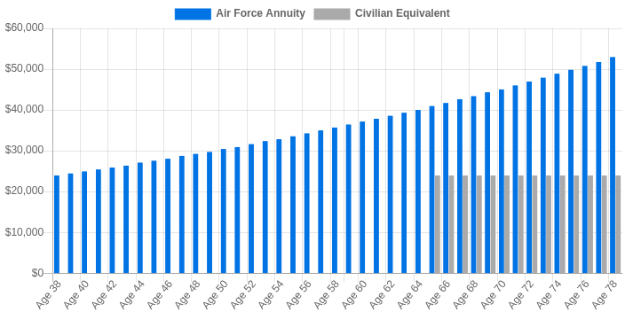

**What this means for me:** Assuming I serve 20 years achieving standard promotions reaching an E8, I could receive an estimated annuity of **$23,957** per year at age **38.** This annuity is cost of living adjusted (COLA) for 2% annual inflation** building to **$40,967** per year at age 65*.  
*\*Assuming an enlistment age of 18.*   
*\*\*2% is the U.S. Federal Reserve’s long-term benchmark for annual inflation.*

**TIP:** Set goals and understand how much you need for retirement. Reinvesting **$1,500 per month** until your actual retirement at **age 65** could grow to roughly **$1.4M** assuming an enlistment age of 18 and average 7% rate of return which is the 30 year average of the [S&P 500](https://www.macrotrends.net/2526/sp-500-historical-annual-returns).

*NOTE: The longer you stay in the Air Force and the higher the pay grades you achieve, the more your yearly retirement annuity will be. It works out to ~2% per year you serve.*

# **09 - Applicant Timeline**

Dear Applicant,

Congratulations on your decision to join the United States Air Force! This application timeline is designed to assist you in managing the items needed to facilitate your application.

In the below application timeline, target dates are listed in order. Some of these items will not be needed for every applicant.

Adhering and following the below dates are imperative to meeting the Basic Military Training date. You must meet the deadlines on time, every time. Any changes to the dates must be approved by an Air Force Recruiting Service Flight Chief.

Congratulations again on your decision to join the greatest Air Force in the world!

|  |  |
| --- | --- |
| Pending Documents: | Date: |
| Source Documents: | **Date:** |
| Medical Documents: | **Date:** |
| Credit Check Documents: | **Date:** |
| Law Violation Documents | **Date:** |
| Dependency Documents: | **Date:** |
| Prior Service Documents: | **Date:** |
| Casefile Return: | **Date:** |
| Credit Check | **Date:** |
| PiCAT Home Test: | **Date:** |
| PICAT Confirmation | **Date:** |
| ASVAB or PiCAT V/TAPAS/CT: | **Date:** |
| Medical Review Submission: | **Date:** |

|  |  |  |
| --- | --- | --- |
| ________________________________  Applicant Name | _______________________________  Applicant Signature | __________________  Date |
| ________________________________  Recruiter Name | ________________________________  Recruiter Signature | __________________  Date |